FPI Migratory Piscivores (Albacore, Black marlin, Blue marlin, Striped marlin)

**Albacore** in the South Pacific are opportunistic carnivores which feed on a wide variety of small fish, planktonic crustaceans, and squid. Stomach contents of juvenile albacore caught incidental to the New Zealand purse-seine fishery and by trolling in the STCZ east of New Zealand have been analyzed by Bailey and Habib (1982) and Bailey (1983, 1986). Bailey and Habib (1982) present data suggesting that diet changes with albacore size. In juveniles smaller than 50 cm LCF, diet is almost exclusively planktonic crustaceans. For juveniles 50–75 cm LCF, diet is a mixture of crustacea, squid, and small fish. Albacore 76–95 cm LCF feed primarily on small fish and squid. Bailey (1983) demonstrates that diet can differ substantially in different regions and that diet appears to be more varied in continental slope compared to continental shelf waters. He further demonstrates a relationship between time of day and fullness of albacore stomachs, suggesting that juvenile albacore feed primarily during morning hours (0900–1200 hours) and early evening (1800–2100 hours). In oceanic areas east of New Zealand, Bailey (1986) reports that juvenile albacore caught by trolling feed on planktonic crustacea, squid, and small fish, with small fish predominating throughout the STCZ area. He further reports differences in the fish prey near New Zealand, where myctophids and saury predominate, in contrast to the central STCZ, where Peruvian jack mackerel predominate in the diet. Examination of stomach contents of adult albacore caught by longline indicates that they also feed primarily on crustacea, squid, and fish (Saito, 1973), with significant differences in stomach fullness occurring in fish caught at different depths. He notes that albacore in the area west of Fiji caught at depths of 80–200 m had less in their stomachs on average than those caught at greater depths (200–380 m). He also noted differences in diet between the shallower and deeper layers, with crustacea predominating in the diet at deeper layers. Albacore feed at the surface.

Larvae: copepods, cladocerans, appendicularians

From Young et al, 2010:

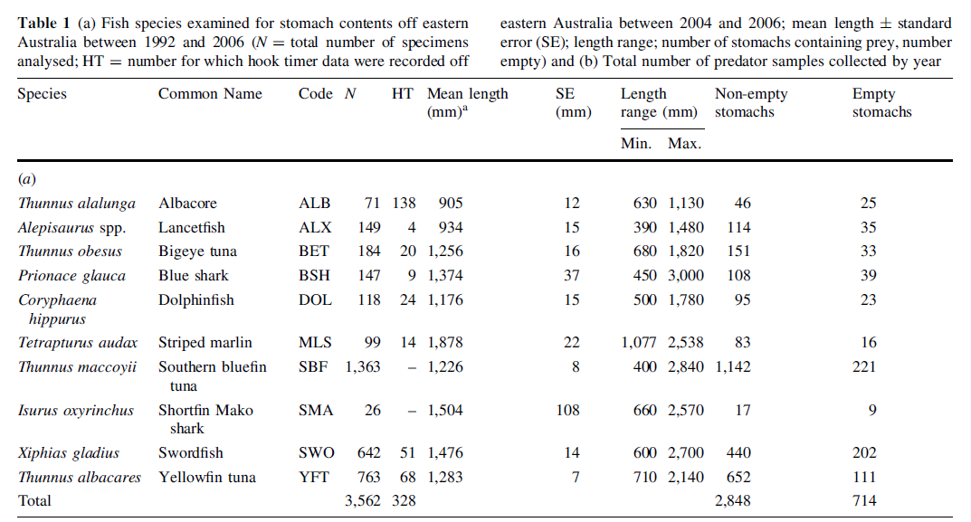

Overall, carangid and scombrid fishes, and ommastrephid squid (particularly Ommastrephes bartramii) were the main prey species found in this study for most of the predators. No one prey species dominated as a major food source, a result similar to that found in other subtropical and temperate pelagic ecosystems (Potier et al. 2007), and contrasting to more tropical systems where often an individual micronekton prey species was dominant (e.g. Vinciguerria nimbaria, Me´nard et al. 2000; Cubiceps pauciradiatus, Bard et al. 2002; Potier et al. 2008). Cannibalism was noted in lancetfish. With the exception of the bigeye tuna, myctophids were not a major contributor to top predator diets but were likely to be, indirectly, very important (Young et al. 2010). Myctophids are a major prey source to many of the prey species, particularly the squid, which are known to be major predators. Three loose predator groupings were identified based on their prey. One group consisted of striped marlin, dolphinfish and yellowfin tuna; a second that included swordfish, albacore and bigeye tuna; and a grouping of blue shark and southern bluefin tuna. yellowfin tuna, dolphinfish and striped marlin were predominantly epipelagic feeders preying on tetraodontid, scombrid and balistid fishes and surface crustacean (Lansdell and Young 2007). Mesopelagic fishes such as those from the Paralepididae and Nomeidae were present in the diet of deeper-living fishes such as swordfish and bigeye tuna. dolphinfish, albacore and swordfish had significantly different diets depending upon where they were caught. Dolphinfish caught in north of 30_S were distinguished by the presence of flying fish (Exocoetidae) in their diets; albacore and swordfish by the presence of a range of squid species. Prey-to-predator length ratios generally increased with mean predator length. Relatively smaller predators (e.g. albacore and lancetfish) had lower ratios than larger predators such as swordfish and shark species. These ratios were, in general, lower than those reported in similar studies. For example, Juanes (1994) reported that prey-topredator ratios of piscivores were mostly between 20 and 30%. Olson and Galvan-Magana (2002) reported ratios of 17% for dolphinfish collected from purse seine nets in the eastern Pacific Ocean. The results of those studies and the present study suggest that prey were relatively small for the same predators in the waters off eastern Australia. This is supported in the case of dolphinfish, which fed on a range of larval and smaller fishes, whereas in the eastern Pacific, small dolphinfish were feeding on flying fish (Olson and Galvan-Magana 2002). The more detailed quantile regression analysis showed that, in general, prey size increased with predator size. With the exception of the sharks, there was widespread feeding on very small prey. Our study agreed with Me´nard et al.(2006) indicating that the median prey size for yellowfin tuna is smaller than that for bigeye tuna. of myctophids (Parry 2006).

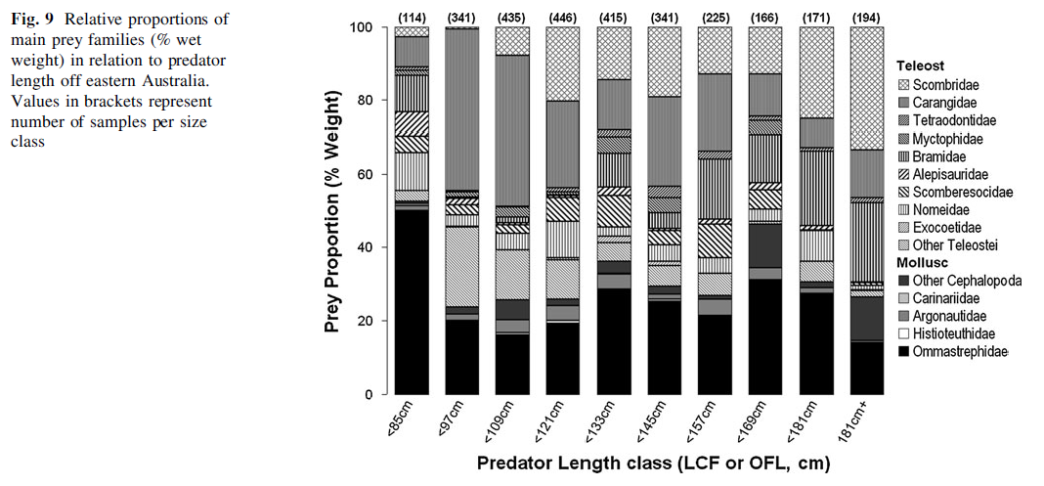

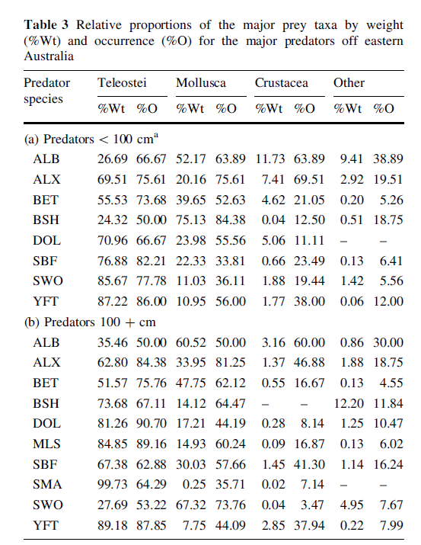

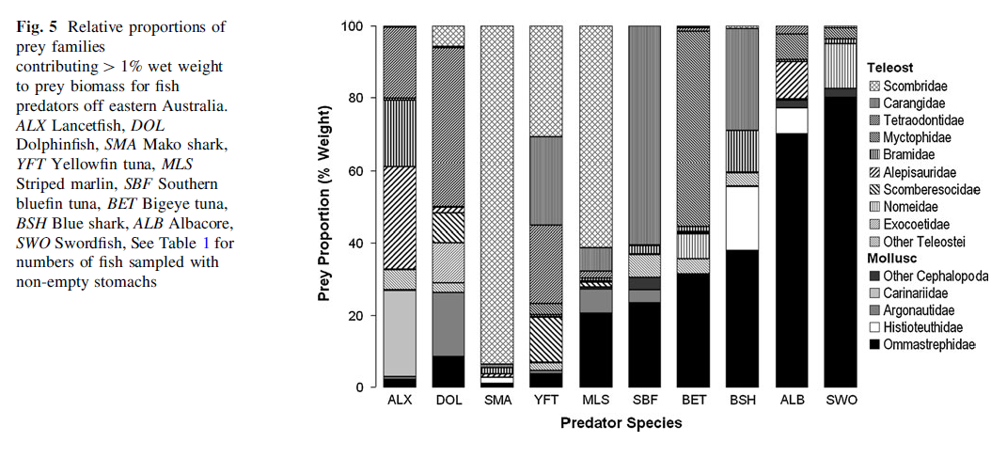

In predators <100 cm, only albacore and blue shark ate more squid than fish (Table 3). In predators>100 cm, albacore and swordfish were the only two predators with a mainly squid diet. Although not comprising a large proportion by weight, crustacean prey consistently occurred in a number of predator species indicating they were also an important dietary component, particularly for albacore and yellowfin tuna.

**Black Marlin** (*Makaira indica*)The species grows to over 4.48 m in length and over 700 kg.

Food items consist largely of other large fast swimming fishes such as tunas, mackerels, trevallies, and swordfish. Less important foods include other fishes, squids, and large crustaceans.

**Blue Marlin (***Macaira nigricans***)** It grows to over 4.47 m in length and over 900 kg. Dietary items include tunas and other fishes. Less important food items include squids and large crustaceans. There were 35 prey species identified; 7 cephalopods, 2 crustaceans, and 26 fish.

Osteichthyes (fish) was the major food group eaten by the blue marlin by volume (89.6%), number (76.5%), occurrence (95%) and index of relative importance (92.6%). The most important species were the bullet mackerel Auxis spp., young finescale triggerfish Balistes polylepis and California pilchard Sardinops caeruleus. Cephalopods were second most important by volume (10.3%), number (22%), occurrence (21.8%), and IRI (7.3%). The family Ommastrephidae, which includes four species, were found in 22.7% of the stomachs. The giant squid Dosidicus gigas was the most important species.

**Striped marlin** (Kajika audax): Based on the index of relative importance (IRI), two cephalopod species were the most common prey: Dosidicus gigas and Argonauta spp. The smallest marlin fed predominantly on Argonauta spp., while larger specimens primarily consumed D. gigas.Albacore <50 cm diet is almost exclusively planktonic crustaceans.

A total of 347 fish of 17 species in 12 families were found in the stomachs of striped marlin. Based on numbers of individuals found, bramids (*Brama* spp.) were dominant in the stomach contents (60.5%), and scombrids had the second highest value (11.0%). Fairly high numbers of stromateoid fish, including nomeids and ariommatids, were consumed. The combined total for these two families was 14.4%. Scombrids had the highest frequency of occurrence, being found in 54.2% of the striped marlin examined. Bramids appeared second most frequently (20.0%), followed by coryphaenids (13.3%), and gempylids and tetraodontids (*Lagocephalus* sp.) (10.4%).

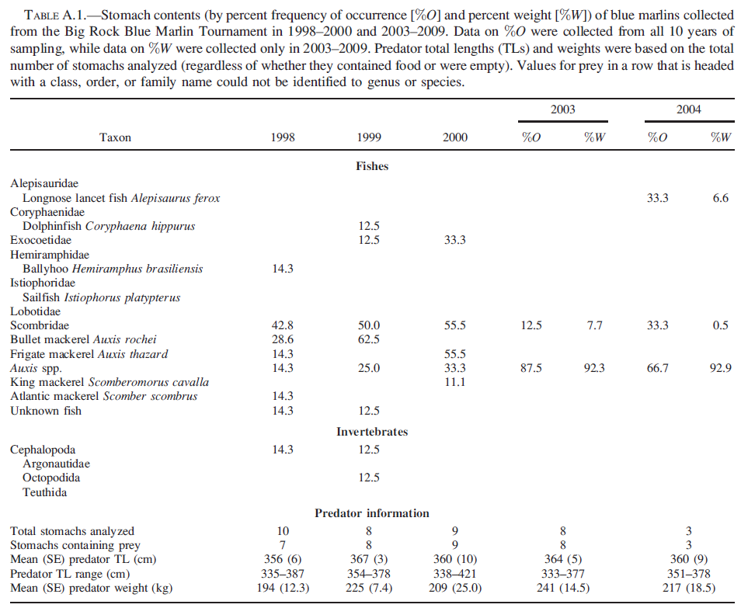

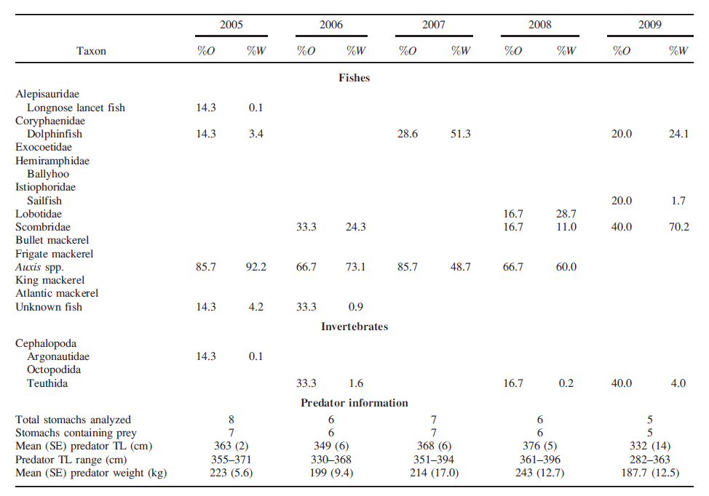

|  |  |
| --- | --- |
| **prey item** | **probability of consuming** |
| ZME zooplankton | 0.3 |

Albacore juveniles 50–75 cm LCF diet is a mixture of crustacea, squid, and small fish

|  |  |
| --- | --- |
| **prey item** | **probability of consuming** |
| ZME zooplankton | 0.3 |
| CEP Cephalopod | 0.3 |
| FMP mesopelagic fish | 0.05 |

Albacore 76–95 cm LCF feed primarily on small fish and squid

|  |  |
| --- | --- |
| **prey item** | **probability of consuming** |
| ZME zooplankton | 0.3 |
| CEP Cephalopod | 0.3 |
| FMP mesopelagic fish | 0.1 |

Albacore >100 cm LCF predators>100 cm, albacore and swordfish were the only two predators with a mainly squid diet.

|  |  |
| --- | --- |
| **prey item** | **probability of consuming** |
| ZME zooplankton | 0.05 |
| CEP Cephalopod | 0.3 |
| FPK pelagic planktivores | 0.05 |
| FMP mesopelagic fish | 0.2 |

Marlin:

|  |  |
| --- | --- |
| **prey item** | **probability of consuming** |
| FPK pelagic planktivores | 0.2 |
| CEP Cephalopod | 0.1 |
| SAR sardines | 0.1 |
| FPP pelagic piscivores | 0.3 |

References

<http://www.fao.org/docrep/005/t1817e/t1817e10.htm>

Bailey, K.N. 1986. A preliminary analysis of the stomach contents of albacore, *Thunnus alalunga*, from the Subtropical Convergence Zone east of New Zealand. Paper presented at the First South Pacific Albacore Research (SPAR) Workshop, 9–12 June 1986, Auckland, New Zealand. *S.Pac.Comm.*, WP/17

Saito, S. 1973. Studies on fishing of albacore, *Thunnus alalunga* (Bonnaterre) by experimental deep-sea tuna long-line. *Mem.Fac.Fish. Hokkaido Univ.*, 21:107–84.

Young, J.W., Davis, T.L.O. Feeding ecology of larvae of southern bluefin,

albacore and skipjack tunas (Pisces: Scombridae) in the eastern Indian Ocean. MEPS 61, 17-29

Jock W. Young Matt J. Lansdell • Robert A. Campbell • Scott P. Cooper • Francis Juanes • Michaela A. Guest Feeding ecology and niche segregation in oceanic top predators off eastern Australia. Mar Biol (2010) 157:2347–2368

Young, J.W. Feeding ecology of marine fish larvae: an Australian perspective. Bureau of Rural Resources Proceedings No. 15, 30-36

Nakamura, I. 1985. FAO species catalogue. Vol. 5. Billfishes of the world. An annotated and illustrated catalogue of marlins, sailfishes, spearfishes and swordfishes known to date. FAO Fish. Synop. No. 125 (5): i-iv, 1-65.

<http://australianmuseum.net.au/Black-Marlin-Makaira-indica-Cuvier-1832>

Leonardo Andres Abitia-Cardenas, Felipe Galvan-MaganÄa, Francisco Javier Gutierrez-Sanchez, Jesus Rodriguez-Romero, Bernabe Aguilar-Palomino, Almei Moehl-Hitz (1999). Diet of blue marlin Makaira mazara off the coast of Cabo San Lucas, Baja California Sur, Mexico. Fisheries Research 44 (1999) 95-100

Veiga, P, Xavier, J.C., Assis, C.A., Erzini, K., 2011. Diet of the blue marlin, Makaira nigricans, off the south coast of Portugal. Marine Biology Research. 7, 820-825.

[Feeding of striped marlin, Kajikia audax (Philippi 1987), from the area off the coast of Mazatlan, Sinaloa, Mexico.](http://apps.webofknowledge.com/full_record.do?product=UA&search_mode=GeneralSearch&qid=1&SID=N22TA2d7yU1ZwILhYvo&page=1&doc=5) Author(s): Abitia-Cardenas, Leonardo Andres; Arizmendi-Rodriguez, Dana Isela; Cruz-Escalona, Victor Hugo; et al. Research Journal of Fisheries and Hydrobiology  Volume: 7   Issue: 1   Pages: 6-13   Published: January-March 2012

Paul J. Rudershausen , Jeffrey A. Buckel , Jason Edwards , Damon P. Gannon ,

Christopher M. Butler & Tyler W. Averett (2010) Feeding Ecology of Blue Marlins, Dolphinfish, Yellowfin Tuna, and Wahoos from the North Atlantic Ocean and Comparisons with other Oceans, Transactions of the American Fisheries Society, 139:5, 1335-1359, DOI: 10.1577/T09-105.1

[Composition of piscine prey in the diet of large pelagic fish in the eastern tropical Pacific Ocean](http://apps.webofknowledge.com/full_record.do?product=UA&search_mode=GeneralSearch&qid=1&SID=N22TA2d7yU1ZwILhYvo&page=4&doc=35)  Author(s): Moteki, M; Arai, M; Tsuchiya, K; et al.Source: FISHERIES SCIENCE  Volume: 67   Issue: 6   Pages: 1063-1074   Published: DEC 2001